# Purpose

The purpose of this document is to provide an explanation of how to use the fatigue test feature on the twister test bench. This documentation as provided represents the state of the fatigue test feature on 9/9/2018.

# Revisions

* 9/9/2018 – Initial release, created by Jeff Anderson.

# Creating a New Test

After selecting Fatigue Test from the main screen, the user must define at least one test condition. Figure 1 shows the information the user must provide. An explanation of each section is given below.

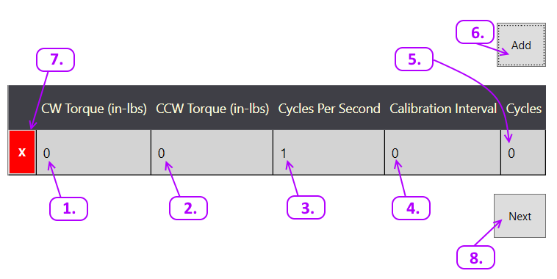

Figure 1: Defining the test parameters.

1. **CW Torque**: The target torque, in inch-pounds, in the clockwise direction, as viewed normal to the gearbox flange face. Allowable values are between -20,000 to +20,000, but clockwise torque must be greater than counterclockwise torque.
2. **CCW Torque**: The target torque, in inch-pounds, in the counterclockwise direction, as viewed normal to the gearbox flange face. Allowable values are between -20,000 to +20,000, but counterclockwise torque must be less than clockwise torque.
3. **Cycles Per Second**: The number of cycles completed in 1 second. A cycle goes from zero torque, to the target clockwise torque, then to the target counterclockwise torque, and finally back to zero. Allowable values are 1-3.
4. **Calibration Interval**: Due to the high cycle speed, the target clockwise and counterclockwise torque values are converted to angular position values which the variable frequency drive can check very quickly. The calibration cycle is a periodic check to ensure that the target position still applies the same amount of torque to the test specimen. There is no limit to the allowable value. The lower the calibration interval, the longer the test will take, but the greater the certainty of the applied torque during the cycles in between the calibration cycle.
5. **Cycles**: The number of cycles to complete. There is no limit to the number of test cycles.
6. **Add**: Adds another test condition at the bottom of the table. There are no limits to the number of test conditions.
7. **Delete**: Deletes the test condition.
8. **Next**: Takes the user to the test monitoring screen.

# Monitoring a Test

After pressing the Next button (figure 1), the test monitoring screen will appear. The purpose of this screen is to provide the user with information about how the test is progressing. It also gives the user the ability to start the test, and if necessary, stop the test.

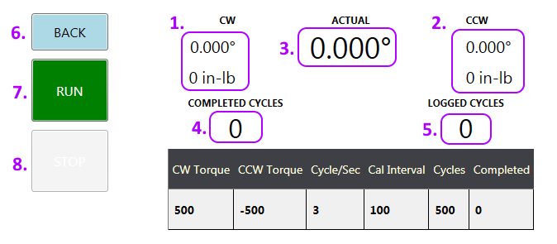

Figure 2: Test monitoring screen just prior to starting the test.

1. Target torque and angle in the clockwise direction.
2. Target torque and angle in the counterclockwise direction.
3. Current angle.
4. The number of cycles that have been completed so far.
5. The number of data points that have been logged so far. Test data is logged to c:\temp\twister.dat. The file is a comma separated value (CSV) file, disguised with the .dat extension. Before a test starts logging data, the existing twister.dat file is renamed and the new twister.dat file contains the current test data.
6. Before the test begins, the user can go back and add more test conditions.
7. The run button starts the test.
8. The stop button is used in emergency stop conditions and will stop the test from cycling and return to the 0° position. This button is disabled before the run button is pressed.

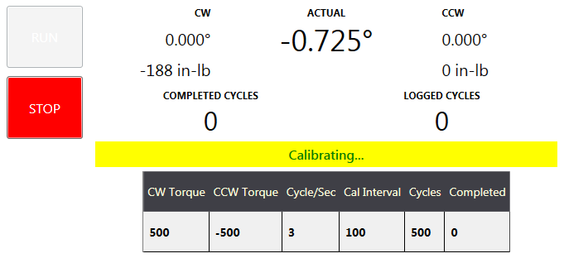

Figure 3: The first calibration cycle.

When the run button is pressed, the screen will appear as shown in figure 3. The stop button will become enabled, and the run button disabled. The calibrating indicator will appear as a yellow bar with the word “Calibrating…” inside.

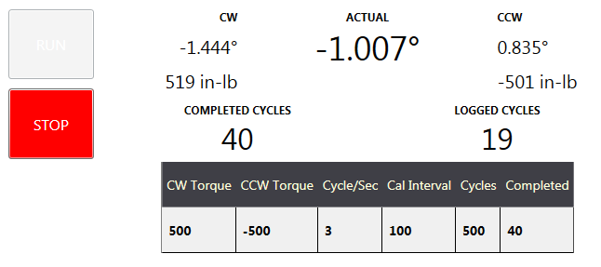

Figure 4: The normal running screen.

The torque and angle values from the calibration cycle will appear, the yellow calibrating bar will disappear, and the completed and logged cycles will begin to increase. By default, data is logged every 10 seconds. The completed cycles will increase as defined in the cycles per second test condition. When all cycles have been completed, the screen will look like figure 5.

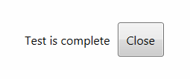

Figure 5: The test is complete. Click the button to close the program.